Project Design Phase-II

Technology Stack (Architecture & Stack)

Date | 03 October 2026
Team ID | —
Project Name | Implement Client Script & UI Policy (Incident)
Program / Module | ServiceNow System Administrator – SkillWallet
Maximum Marks | 4 Marks

Technical Architecture:
The architecture represents the application logic and technology blocks used to implement Client Scripts and UI Policies for the ServiceNow Incident table. The solution is primarily platform-based, with client-side behavior executed in the ServiceNow user interface and Incident data maintained by the ServiceNow platform.
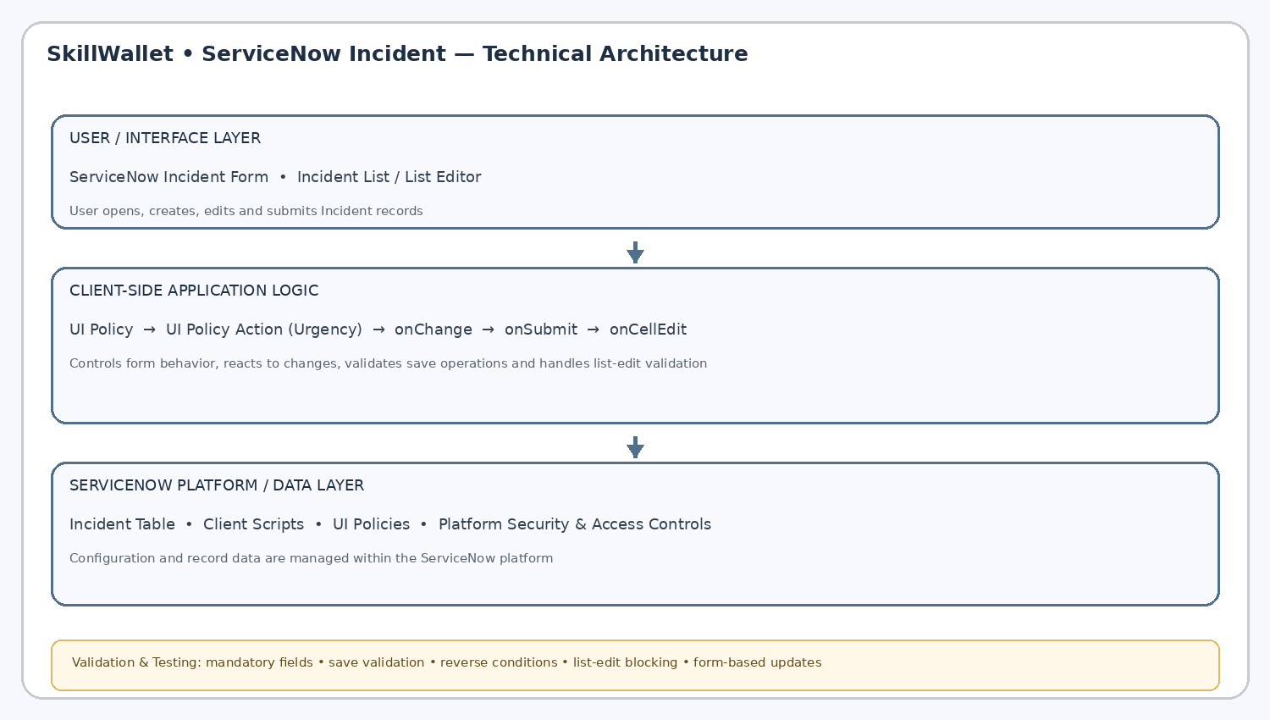
Architectural considerations: application processes are represented as ServiceNow configuration and client-side logic; the Incident table is the primary data component; platform security/access controls protect records; the project does not require an external API or
machine-learning model.

Table-1 : Components & Technologies

S.No | Component | Description | Technology
1 | User Interface | Interface through which users create, view, edit and submit Incident records. | ServiceNow Incident Form, Incident List / List Editor
2 | Application Logic-1 | Controls Incident form behavior according to defined conditions. | UI Policy
3 | Application Logic-2 | Applies the UI Policy behavior to the Urgency field. | UI Policy Action
4 | Application Logic-3 | Responds to field changes and performs client-side save/list validation. | onChange, onSubmit and onCellEdit Client Scripts
5 | Database | Stores Incident records and their field values within the platform. | ServiceNow Incident Table
6 | Cloud Database | Platform-managed data service for the ServiceNow application. | ServiceNow Platform Data Layer
7 | File Storage | No dedicated project file-storage component is required by the supplied project scope. | Not applicable

S.No | Component | Description | Technology
8 | External API-1 | No external API is specified for the project. | Not applicable
9 | External API-2 | No second external API is specified for the project. | Not applicable
10 | Machine Learning Model | No machine-learning model is required for the Client Script/UI Policy implementation. | Not applicable
11 | Infrastructure (Server / Cloud) | Application and configuration are delivered through the ServiceNow platform rather than a separately deployed project server. | ServiceNow Cloud Platform / Instance

Table-2: Application Characteristics

S.No | Characteristics | Description | Technology
1 | Open-Source Frameworks | The supplied project scope does not specify an external open-source framework. The implementation uses ServiceNow-native configuration and scripting capabilities. | ServiceNow UI Policies and Client Scripts
2 | Security Implementations | Access and record protection are handled within the ServiceNow platform. Client-side validation supports correct user interaction but should complement platform-side access controls. | ServiceNow roles / ACLs and platform security controls
3 | Scalable Architecture | The implementation is configuration-driven and can be extended with additional Incident fields, UI Policies and Client Scripts without changing the overall platform architecture. | ServiceNow platform configuration model
4 | Availability | The application is accessed through the ServiceNow instance; the project does not specify separate load-balancing or distributed-server components. | ServiceNow hosted platform / instance
5 | Performance | Client Scripts should execute only the required validation or field-behavior logic to keep Incident forms and list editing responsive. | Client-side JavaScript execution within ServiceNow

Implementation Flow
1. User interacts with the Incident form or list → 2. UI Policy evaluates the configured condition → 3. UI Policy Action controls the Urgency field → 4. onChange responds to field changes → 5. onSubmit validates the record before save → 6. onCellEdit validates list-based changes → 7. Incident data remains within the ServiceNow platform.

References:
The uploaded template lists C4 model, IBM architecture, AWS architecture and technical-architecture guidance as references. They are retained here as template references; no additional external research was used to define the project-specific stack.
- https://c4model.com/
- https://developer.ibm.com/patterns/online-order-processing-system-during-pandemic/
- https://www.ibm.com/cloud/architecture
- https://aws.amazon.com/architecture
- https://medium.com/the-internal-startup/how-to-draw-useful-technical-architecture-diagrams-2d20c9fda90d

